International Food Safety Summit 2013
Innovation·Fusion·Improvement
Jan 9th, 2014 Add：Beijing
The Invitative Letter Of International Food Safety Summit 2013
To Respect Unit,
Food safety,which as a system of Industry chain management process, plays important role in terms of how to coordinate the interests of the whole industrial chain parties; micro control the safety management of whole industry chain; establish the safety tracking system of the whole industrial chain from agricultural planting (Breeding) --- deep processing --- Circulation --- food safety on table; strengthen the food industry safety management, technology and equipment innovation, upgrade test technology and products, improve the testing level of food safety,business model innovation; establish business strategies for food enterprises, enhance the brand value of food safety, achieve enterprises profit increase. Food safety is the biggest challenge of the food business operators and government supervisions.
International Food Safety Summit 2013 is organized by Global Food Safety Forum (GFSF), which is undertaken by BRIC with the topic of “Innovation, Fusion, improvement, and will be held on Jan 9th, 2014.
Government officials home and abroad, food experts, enterprise managements, Scientific Research Institutes, Food sciences, Food Safety,Supervision,Production,Processing, import and Export Department representatives, dairy product enterprises, Investment institutions and top 500 companies will join together to discuss the huge plan of food safety development. In the mean time, the summit will also announced the winners of “ GFSF innovation persons of the year 2013”,“ new food resources leaders 2013”, “ top 10 new resources foods 2013 ,“ China top 10 food safety tracking systems 2013 ,etc. We welcome related enteritises and organizations to participate in actively.
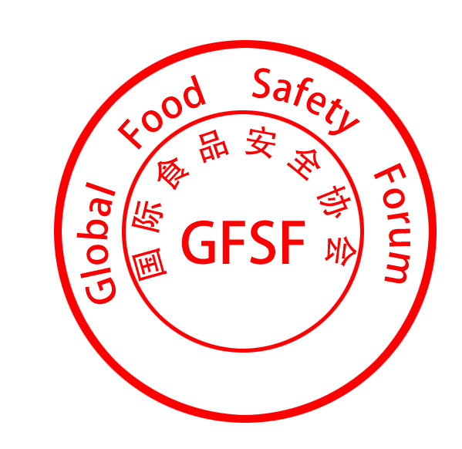
GFSF 12.19.2013
Summit introduction
【Conference theme】：Innovation Fusion Improvement
【 Date 】：January 9, 2014
【Address】：People's Daily （ 4 Lecture Halls 17 Building of the People's Daily JinTai Road Chaoyang District Beijing）
【Organization】：
Organizer：Global Food Safety Forum (GFSF)
Supporters：Food and Agriculture Organization (FAO),World Health Organization(WHO),China Merchandise Reserve Management Center, Pfizer, Novus International, FDA, AB sciex, GAP, China Food Newspaper、China Dairy Industry Association.
【Co organizer:】Beijing Sanyuan Foods Group, Shuanghui Group, Longping High-Tech Group,
【The undertaker】BRIC(Beijing) Food Safety Technology Management Inc.
【website】：http://www.gfsf.org.cn
【Media】：
People's Daily , Xinhua News , CCTV, Economic Daily, Guang ming Daily, China Food Newspaper, 21st Century Economic Report, CCN, France TV, The Daily Globle, , Daily consumption, Farmer daily, Food Science,The new food,The first food network, Sina networks , Tencent networks , International Food Safety Forum , Agricultural products purchase network. The awards ceremony will be the climax of the summit, which is also the highest honor palace of food field.
【Invited guests】：
★ Leaders and experts
The NPC education director of Science Committee Bai Keming
Director of the Food Safety Commission of the State Council Zhang Yong
Deputy director of the State Food and Drug Administration Bian Zhenjia
South Korean Agriculture Technology Consortium Song Wen (South Korea)
President of Korean Association of agricultural products Li Chunxin (South Korea)
President of the Global Food Safety Forum Rick Gilmore (USA)
Vice chairman GFSF Helen, Darlene (New Zealand)
French Embassy in China Ai Ruilian (France)
Embassy of the Republic of Thailand, Minister Wu Lile (Thailand)
The Russian Federation of chamber of Commerce and industry
chief representative in China Berogio Rolf (Russia)
Novus International Sun Defa

AB sciex Wang Haijian
Good agricultural practices（G A P） Zhang Zhiqiang
Longping High-Tech Zhou Dan
Longcom Group Xu Zhenyu
Associate professor of China Jiliang University Yang Yong
Vice chairman, Global Food Safety Forum, vice president of China Food Newspaper
Zhang Jianbin
Vice chairman, Global Food Safety Forum & China Merchandise Reserve Management Center president Yuan Yongkang
Vice president and Secretary of the association of international food safety Sun Tong
Vice president of the Global Food Safety Forum Jiang Fuming
Shuanghui group Wan long
Guangming group Ge Junjie
Legend Holdings Chen Shaopeng
【Special activities】
Agenda
Date | Conference name | The topic of the meeting
Part 1: Registration
Jan 8th | Registration | Registration and get documentation
Part 2: General assembly

Jan 9th Morning | The 2013 International Food Safety Summit -- Opening Ceremony | Witness the development of food industry
Jan 9th Morning | The 2013 International Food Safety Summit -- assembly | Innovation, fusion, improvement
Part 3: Special sub-meeting
Jan9th Afternoon | The 2013 International Food Safety Summit -- enterprise diagnosis (investors) | Experience, business model, profit model  Consultation to avoid risk
Jan9th Afternoon |  | Facing the capital
Jan9th Afternoon | The 2013 International Food Safety Summit -- purchasing docking | The centralized procurement matchmaking
Jan9th Afternoon |  | face to face with buyers
The fourth part: the awards ceremony
Jan 9thEvening | The 2013 international food safety annual summit and the GFSF billboard  The awards ceremony  (jointly organized and sponsored by the CCTV-7) | The peak and glory

The above schedule is for reference only, will change depends

Return receipt list
Company Name |  |  |  |  |  |  |  |  |  | Website
Name |  |  | Title |  |  | Tel |  |  |  | Cell phone
Name |  |  | Title |  |  | Tel |  |  |  | Cell phone
Address |  |  |  |  |  |  |  |  |  | Zip code
Contact person |  |  |  | Cell phone |  |  |  |  |  | Fax
Tel |  |  |  | E-mail
Note |  |  |  |  |  |  |  |  | Date: Year Month

Contact： Commissioner--Frank Liu (Global Food Safety Forum)
Telephone：010- 57180533 Cellphone：18101051225
Fax：010-82101436
E-mail：liuhj @accfutures.com Website：http://www.gfsf.org.cn
Address：2808 office Tianzuo Globle Centre 12 Zhongguancun South Street
HaiDian District Beijing City China. Zip code;100081

